Talha Yousaf
2025-CE_93
Explanation
Experiment 1
Measure Current between R1 and R2, and Voltage across R1, R2.
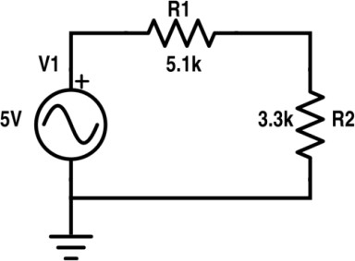
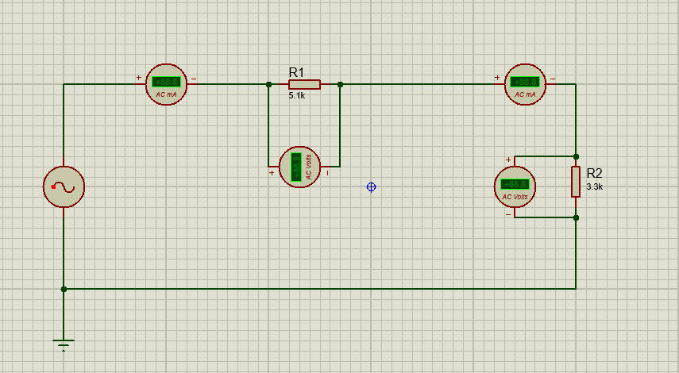

"In this simulation, I have constructed an AC (Alternating Current) circuit to observe how voltage and current behave across resistive loads in an oscillating system. I used a sine wave signal generator as my primary power source."

Setup: I placed two resistors, R_1(5.1kΩ) and R_2 (3.3kΩ), in a series configuration. To monitor the circuit in real-time, I integrated four measurement tools.
I am using two AC Ammeters to verify that in a single-loop series circuit, the current remains constant at all points. I also placed AC Voltmeters across each resistor to observe the individual voltage drops.

Experiment 2
Measure Current at node 2 and 3 and Voltage across R1, R2, R3.

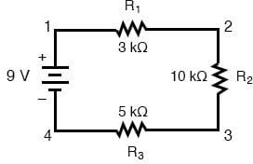
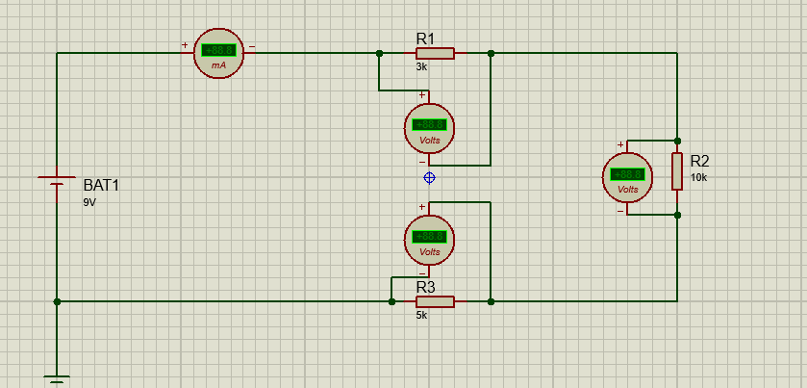

"For my second circuit, I built a DC (Direct Current) series network using a 9V battery (BAT1). This setup is designed to act as a Voltage Divider, illustrating how a source voltage is distributed across multiple components based on their resistance values."
Setup: I connected three resistors in series: R1(3kΩ),R3 (5kΩ), and R2(10kΩ). I purposely chose different resistance values to show the proportional relationship between resistance and voltage drop.
I placed a DC Ammeter at the start of the circuit to find the total current
I connected three DC Voltmeters—one across each resistor—to capture the specific potential difference for each component.

